Team Contract Draft
Course: Senior Design
Date: 09/14/2025
Team Name: SUPAWORKERS
Team Members:
- Jubin Shaikh – Computer Science – shaikhjn@mail.uc.edu
- Namra Ankoliya– Computer Science – ankolina@mail.uc.edu
- Krish Patel – Computer Science – patel7kt@mail.uc.edu

Project Focus
Our team project will focus on designing and implementing a secure full-stack web application. The main emphasis will be on user authentication, session management, database security, and protection against common web vulnerabilities. Along with security, we aim to build a practical and user-friendly application that highlights both functionality and defense.
Meeting Schedule
- Weekly Team Meetings: We will meet once a week, subject to everyone’s availability.
- Check-ins: We will communicate informally through our group chat through Discord to handle quick updates or issues that arise between meetings.
- Advisor Updates: We will provide regular updates to our faculty advisor and adjust our project plan based on their feedback.
Roles (Initial Draft)
- Project Manager (Security/Testing Lead): Oversees scheduling, communication, and ensures deadlines are met. - Jubin Shaikh
- Frontend Lead: Responsible for the UI/UX design and user-facing functionality. - Namra Ankoliya
- Backend Lead: Responsible for server logic, database integration, and API development. - Krish Patel
These roles are flexible and will be refined further in Assignments #5 and #6.
Agreement
As a team, we agree to:
- Respect each other’s time and contributions.
- Be punctual for meetings and communicate in advance if unable to attend.
- Share responsibilities fairly and support each other when challenges arise.
- Address conflicts professionally and resolve them constructively.
Advisor Approval:
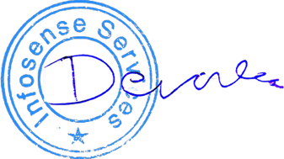
Faculty Advisor Name: Devang Patel
Signature/Approval:

